DPCT065 analysis：

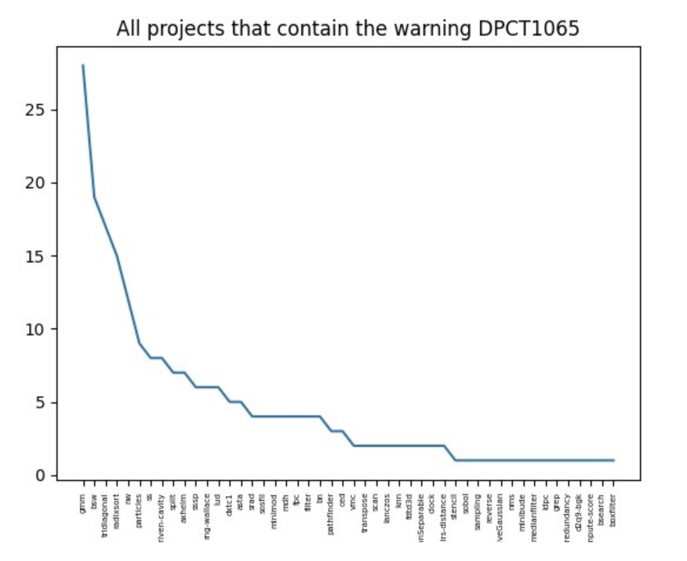

1. Total number of DPCT1065 warning： 230
2. Total number of project have this warning: 49
3. Total number of files have this warning: 59
4. Number of project missing the dpct-version: 11
5. Number of files missing the dpct-version: 13
6. Available projects have this warning: 38
7. Available files have this warning: 46

Warning message：

Consider replacing sycl::nd_item::barrier() with sycl::nd_item::barrier(sycl::access::fence_space::local_space) for better performance, if there is no access to global memory .

1. Only 16 of them accept the alternative proposal. Change from “item_ct1.barrier();” to ” item_ct1.barrier(sycl::access::fence_space::local_space);”
2. Only 1 of them (num) is : *pointsbitmap = (item_ct1.barrier(), sycl::ONEAPI::all_of(item_ct1.get_group(), cond));
3. Others accepted the DPCT proposal;

File /fdtd3d/dpcpp/FDTD3dGPU.dp.cpp:

1. Special cases

changed from “tem_ct1.barrier();” to totally different way

Summary:

The code changes in two ways:

1. Accept the DPCT alternative proposal:

changed from “tem_ct1.barrier();” to “item_ct1.barrier(sycl::access::fence_space::local_space);”

1. Accept the DPCT proposal:

tem_ct1.barrier();

1. Special case

*pointsbitmap = (item_ct1.barrier(), sycl::ONEAPI::all_of(item_ct1.get_group(), cond));